KB article (Accessing Different Services with Multi-Factor Authentication) KB0013206

KB article: https://ucf.service-now.com/ucfit?id=kb_article&sys_id=8d45fc00877985109e222f49cebb3552

Using MFA on Enterprise VPN (secure.vpn.ucf.edu)

Recommendation: UCF IT recommends using the Duo Mobile App (available from Apple or Google app stores) for the best experience.

Please follow the important instructions listed below to get started.

- Enroll your Mobile device: https://guide.duo.com/enrollment
  - iPhone Device: https://guide.duo.com/iphone
  - Android Device: https://guide.duo.com/android

The Duo website (https://guide.duo.com/) has additional information that can help you with MFA.

For instructions on how to install the Cisco AnyConnect Client please follow the instructions in the knowledge base article.
KB article (KB0010298): https://ucf.service-now.com/ucfit?id=kb_article&sysparm_article=KB0010298&sys_kb_id=ff89f4764f45e200be64f0318110c763&spa=1

Signing On:
When you sign on to the Enterprise VPN (secure.vpn.ucf.edu), you will use the UCF Federated ID page and then be prompted to MFA.

- Log in to the Enterprise VPN (secure.vpn.ucf.edu) and choose your login Group (UCF faculty/staff or UCF students) from the dropdown menu.
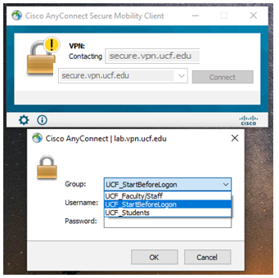

- Sign on using your NID and NID password.

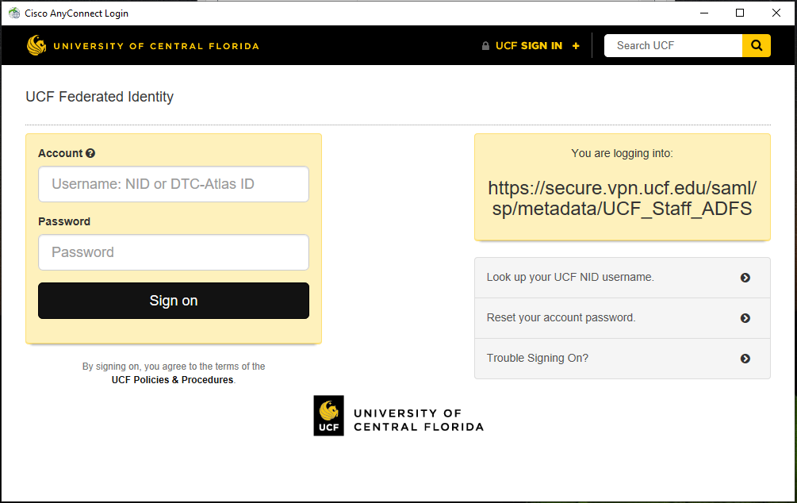

- Choose your authentication method (Duo Push is recommended)
Note: If you are not already enrolled in Duo MFA, please follow the online instructions above to enroll in Duo MFA.
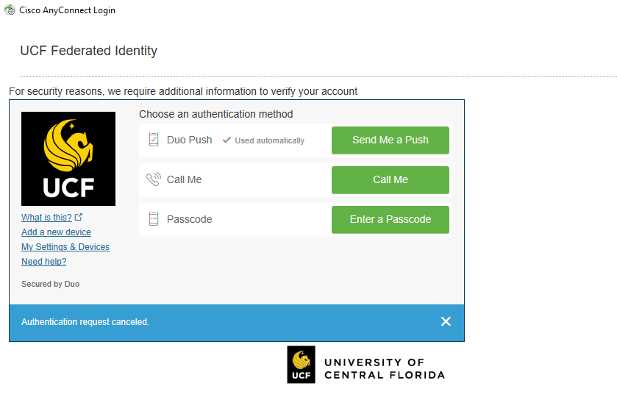

- Confirm your identity (example of a mobile device’s Duo Push challenge option shown below)
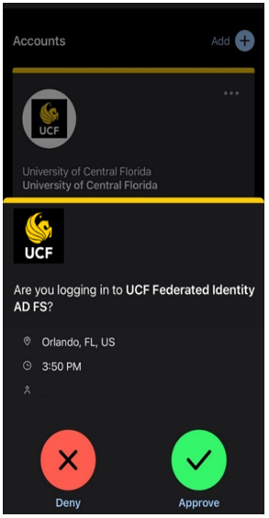

- Accept UCF System User Agreement to be connected to the VPN.

