KB article (UCF Enterprise Virtual Private Network (VPN) Access) KB0010298
KB article: https://ucf.service-now.com/ucfit?id=kb_article&sysparm_article=KB0010298&sys_kb_id=ff89f4764f45e200be64f0318110c763&spa=1
This guide will provide information about connecting to the UCF Enterprise VPN network.
A Virtual Private Network (VPN) provides a secure connection between your local network and a remote network. UCF offers a VPN for employees and students who need to be able to access campus resources from a remote location. This is possible through software known as Cisco AnyConnect. When running the Cisco AnyConnect client, you will be able to access resources within the UCF Campus as if you were onsite.

Cisco AnyConnect Installation and DUO enrollment
Install the Cisco AnyConnect client from the UCF Enterprise VPN Website:
- Visit https://secure.vpn.ucf.edu
Note: You will need to have JavaScript enabled to detect what operating system you're using automatically. Please ensure that you visit the website using a modern browser that supports JavaScript.
- Sign-on requirements
  - Enter your username and password (i.e., Your NID and NID Password)
  - Select the appropriate group: ("UCF Faculty/Staff” or "UCF Students")
  - Complete the Multi-factor Authentication (MFA) challenge
    - We recommend using the Duo Mobile App (available from Apple or Google app stores) for the best experience. Please follow the important instructions listed below to get started.
    - Enroll your mobile device: https://guide.duo.com/enrollment
    - iPhone Device: https://guide.duo.com/iphone
    - Android Device: https://guide.duo.com/android

- If you are using a computer issued by UCF, you can access the Software Center (a catalog of applications you can install yourself) by clicking the start menu and typing in “software center”, you can search for the AnyConnect Client from Software Center.

  - Opened the Software Center by clicking the windows start menu and search for “Software Center”, in the Software Center Application search for the Cisco AnyConnect and click on install to install the software (see picture below).

  - NOTE: If you do not have access to the application in Software Center, please use the following information to contact the UCF Service Desk for assistance.

UCF Service Desk:
- Phone: 407.823.5117
- Email: itsupport@ucf.edu
- Hours: Monday to Friday, 7 a.m. to 10 p.m.
- Website: it.ucf.edu
Open Software Center and search using the keywords “Cisco” or “AnyConnect” and click Install
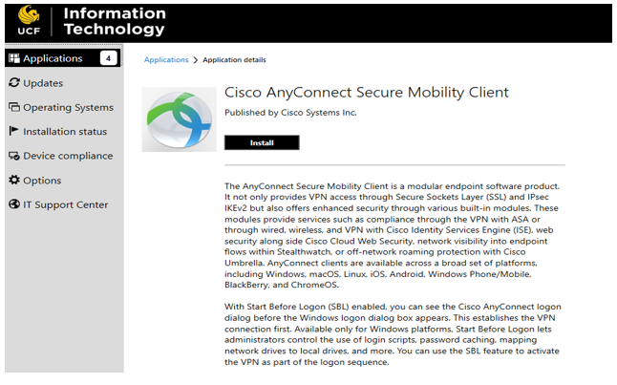

Connect to the VPN:
When you sign on to the UCF Enterprise VPN (secure.vpn.ucf.edu) with Cisco AnyConnect Client, you will be prompted to sign on with the UCF federated ID page and then be prompted for MFA.

- Log in to the UCF Enterprise VPN (secure.vpn.ucf.edu) and choose your login Group (UCF faculty/staff or UCF students) from the dropdown menu.

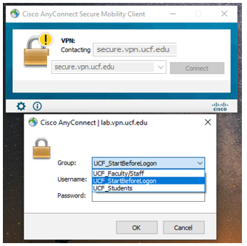

- Sign on using your NID and NID password.

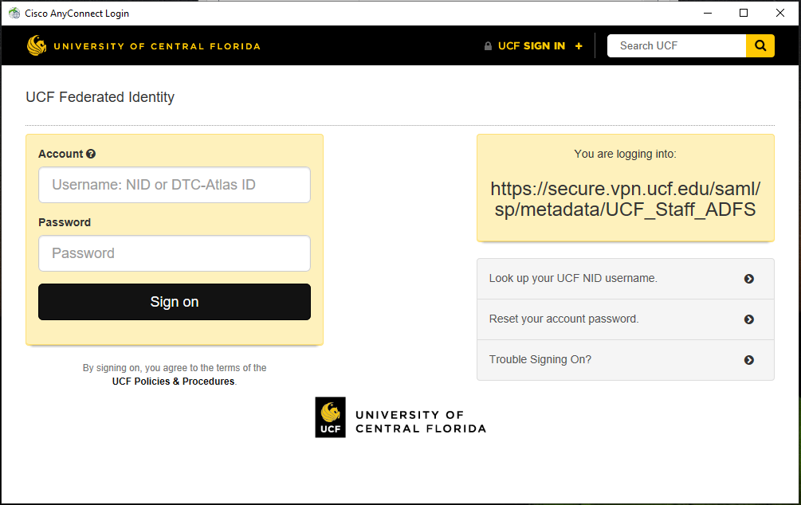

- Choose your authentication method (Duo Push is recommended)
Note: If you are not already enrolled in Duo MFA, please follow the online instructions above to enroll in Duo MFA.

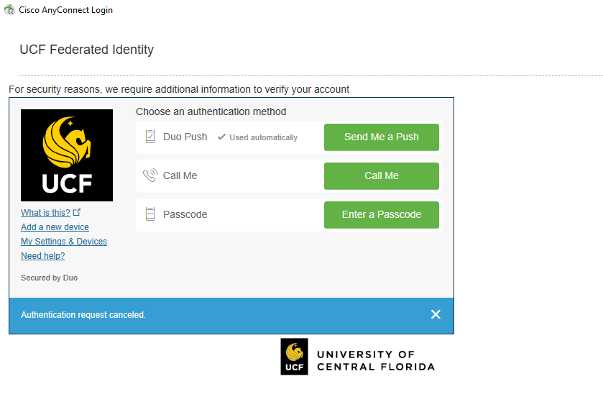
- Confirm your identity (example of a mobile device’s Duo Push challenge option shown below)
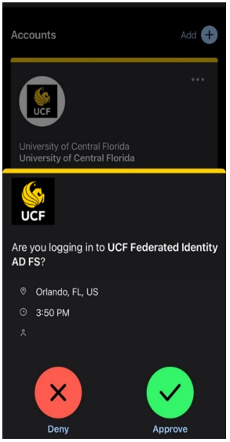

- Accept UCF System User Agreement to be connected to the VPN.

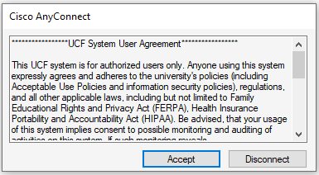

If you cannot access a resource (server, remote desktop connection), then please contact the administrator for that resource.
- If you are unsure of who the administrator is, please contact the Service Desk:
  - Phone: 407.823.5117
  - Email: itsupport@ucf.edu
  - Hours: Monday to Friday, 7 a.m. to 10 p.m.
  - Website: it.ucf.edu

Automatic Upgrade Troubleshooting:

OSX
The Cisco AnyConnect sometimes fails when the software attempts to upgrade itself. If you are running OSX 10.13 (High Sierra), you will need to download and install the Cisco AnyConnect Client according to the above instructions.
Users logging into the updated Cisco AnyConnect VPN may be prompted to install a new version of the software. A “System Extension Blocked” alert will direct you to the System Preferences menu and Security & Privacy option to enable the Cisco AnyConnect Client software extension.

Windows
If you experience issues with the AnyConnect Automatic Update process, you should uninstall AnyConnect from your system. Using the latest version (according to the instructions at the top of this document) you will then reinstall AnyConnect. If you are using a UCF Domain computer and do not have administrator access, please use the following information to contact UCF Service Desk for assistance.
UCF Service Desk:
- Phone: 407.823.5117
- Email: itsupport@ucf.edu
- Hours: Monday to Friday, 7 a.m. to 10 p.m.
- Website: it.ucf.edu
Linux
Additional instructions for Linux can be found here: https://ucf.service-now.com/ucfit?id=kb_article&sys_id=413297561b97c4105cd6b912cd4bcba9

Appendix A. The UCF VPN server provides:
- Access to many systems located behind UCF's network firewall
- Remote access to a system running Windows Remote Desktop, Apple Remote Desktop, or Virtual Network Computing (VNC)
- Network file sharing to properly registered servers on the UCF campus
- Student access to internal systems for class projects and testing
- Supports up to 256-bit AES encryption

